Paper Title Here

First Author∗*,*1*,*3, Second Author2, and Third Author1

1*Department of Civil and Environmental Engineering, Carleton University, Ottawa, Canada* 2*Department of Civil Engineering, University of Ottawa, Ottawa, Canada*

3*National Research Council, Ottawa, Canada*

∗*Corresponding author’s email:* aaa@carleton.ca

**Abstract:** Write the abstract of the paper in this allotted space. The abstract should be a maximum of 200 words.

# Introduction

This is the MS Word template for the full papers of the 4*th* Pan-American Conference on Unsaturated Soils, June 2025, Ottawa, Canada. It includes examples of headings, figures, equations, and tables. Please use the correct provided “Style” for the text and headings. The length of the paper should not exceed **10 pages**, including references.

# Formatting Equations, Figures, and Tables

This is a new section. The style of the title is given as Heading 1. Use the following format for your equations, figures, and tables. Equations, figures, and tables should be numbered and appropriately referred to in the text.

## Gibbs-Thomson Relation

This is a sub-section. The style of the title is given as Heading 2.

The Gibbs-Thomson equation determines the critical pore radius below which the water is at a liquid state and can be described as follows:

where *Tm* is the melting point of water in the pores, *T*0 is the melting point of pure liquid water, *γsl* is the free energy coefficient of the ice–water interface, *ρi* is the ice-phase density, *Lf* is the latent heat of phase transformation, and *R* is the pore radius [1]. The variation of freezing temperature with pore radius, as predicted by Eq. 1 is shown in Fig. 1. The relation has been used for deriving the freezing characteristics curve, see for instance [2].

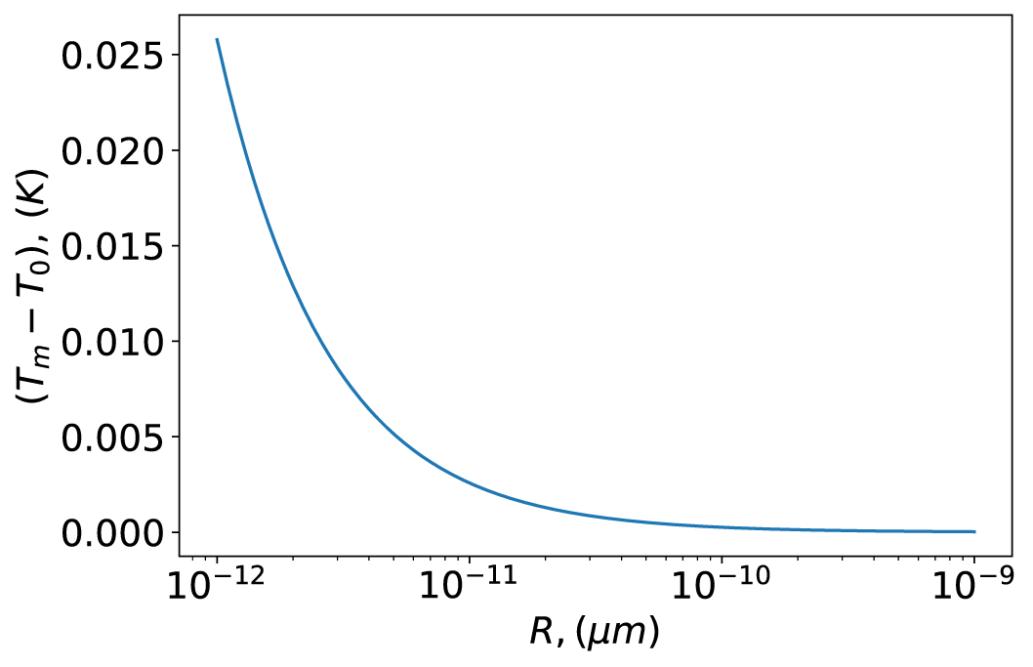  
Figure : Gibbs-Thomson relation for freezing temperature of water in pores with varying radii.

Table : Parameters for water and ice for Gibbs-Thomson equation (1).

|  |  |  |  |
| --- | --- | --- | --- |
| *T0*(*K*) | *γsl* (*J m*−2) | *ρi* (*kg m*−3) | *Lf* (*J kg*−1) |
| 273*.*15 | 0*.*029 | 917 | 3*.*35 × 105 |

# Reference Style

Use the provided style for citation and referencing.

# Submitting Your Paper

Please upload the final version of your paper as a single PDF file to the conference webpage at [https://www.panam-unsat2025.ca.](https://www.panam-unsat2025.ca/)

# References

1. É Devoie, S Gruber, and J McKenzie. A repository of measured soil freezing characteristic curves: 1921 to 2021. *Earth System Science Data*, 14(7):3365–3377, 2022.
2. MM Zhou and G Meschke. A three-phase thermo-hydro-mechanical finite element model for freezing soils. *International Journal for Numerical and Analytical Methods in Geomechanics*, 37(18):3173–3193, 2013.
3. D. G. Fredlund and H. Rahardjo. *Soil mechanics for unsaturated soils*. John Wiley & Sons, 1993.
4. D. Evans. Unsaturated flow and transport through fractured rock-related to high-level waste repositories. Final report. Phase I. Technical report, Arizona Univ., Tucson (USA). Dept. of Hydrology and Water Resources, 1983.